Hackathon Submission (Level-1-Solution)

Use Case Title: AI-Powered Movie Recommendation System

Student Name: NIVETHA.V Register no:410623243064

Institution: Dhaanish Ahmed College of Engineering Department: Artificial intelligence and datascience Date of Submission: 18.05.2025

1. Problem Statement

*In the modern digital era, film enthusiasts are bombarded with options. Streaming services have enormous collections, but viewers find it difficult to discover movies that suit their tastes.*

*Conventional recommendation algorithms tend to be based on popularity alone or simple user preferences, leading to generic recommendations that do not cater to individual viewing experiences.*

*This project seeks to build an AI-powered matchmaking system extending beyond basic content filtering. Through integrating machine learning principles and behavioral analysis, our system dynamically adjusts to users' interests, moods, and changing preferences. It aspires to build an immersive, intuitive recommendation engine that enhances entertainment experiences and promotes user engagement.*

1. Proposed Solution

*This project utilizes AI to provide highly personalized movie recommendations using a refined matchmaking strategy. Through the integration of collaborative filtering, natural language processing (NLP), and sentiment analysis, we seek to enhance the recommendation process.*

*Project key components are:*

* + *User Profile Analysis: Interpreting viewing history and explicit ratings.*
  + *Emotion-Based Matching: Interpreting user feedback and sentiment to adapt suggestions.*
  + *Hybrid Recommendation Model: Integrating content- based and collaborative filtering for increased accuracy.*
  + *Real-Time Learning: Generating recommendations based on user interactions.*

*The final system will be implemented as an interactive web application using Flask or Gradio, offering a user-friendly interface that makes it easily accessible.*

1. Technologies and Tools used:

Programming Languages

* Python (Primary for AI/ML, data pre-processing, and backend logic)
* JavaScript (Frontend development with React.js)
* HTML/CSS (UI structure and styling) Machine Learning & AI Frameworks
* Scikit-learn (For collaborative/content-based filtering)
* Tensor Flow/Keras (Neural Collaborative Filtering/NCF)
* NLTK (Natural Language Processing for sentiment analysis)
* Surprise/LightFM (Hybrid recommendation models) Data Processing & Libraries
* Pandas/Numpy (Data manipulation and feature engineering)
  + Matplotlib/Seaborn (EDA visualizations)
  + One-Hot/Label Encoding (Categorical data pre-processing)
  + Standard Scaler (Feature normalization) Backend & Deployment
  + Flask/FastAPI (Backend API development)
  + Netlify (Frontend deployment)
  + Google Colab/Jupyter Notebook (Prototyping and model training) Frontend Technologies
  + React.js (Interactive UI components)
  + React Icons (FaFilm, FaSearch) (UI elements)
  + React Router (Navigation)
  + Tailwind CSS (Styling)

APIs & External Services

* + TMDB API (Movie metadata, posters, ratings)
  + IMDb API (Alternative dataset)
  + User Input API (Custom sentiment/behavioral analysis) Database & Storage
  + CSV/JSON (Local dataset storage)
  + Pandas DataFrames (In-memory data handling)

1. Solution Architecture & Workflow

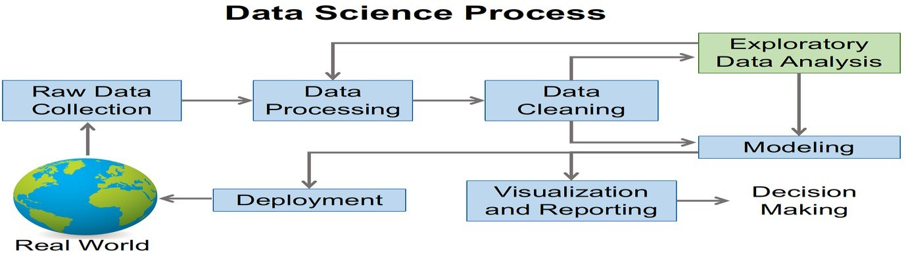

1. Feasibility & Challenges

Feasibility: Why This Solution is Practical Proven Technologies:

* Uses well-established tools like Python (Scikit-learn, Tensor Flow), React.js, and Flask, which have extensive documentation and community support.
* Hybrid recommendation models (collaborative + content-based filtering) are a tested approach in industry (e.g., Netflix, Spotify).

Scalable Architecture:

* Modular design (data preprocessing → model training → API

* UI) allows incremental improvements.

- Cloud-ready (Netlify for frontend; could extend to AWS/GCP for backend scaling).

Cost-Effective:

* Open-source libraries (Pandas, NLTK) and free-tier APIs (TMDB) reduce licensing costs.
  + Lightweight deployment options (Flask + Netlify) suit small-to- medium datasets.

User-Centric Design:

* + Interactive UI (React.js) and real-time updates (e.g., sentiment analysis) enhance engagement.
  + Explainable recommendations (e.g., "Recommended because you liked Action movies") improve trust.

Challenges and Mitigation Strategies:

| Challenge | | Potential Solution |

| Data Sparsity | Use matrix factorization (SVD) or deep learning (NCF) to handle sparse user-item interactions. |

| Cold Start Problem | Hybrid models + demographic/popularity- based fallbacks for new users/items. |

| Scalability | Migrate to distributed systems (Apache Spark) or cloud ML (AWS SageMaker) for large datasets. |

| Bias in Recommendations | Regularize models to avoid overfitting to popular items; diversify outputs with serendipity scores. |

1. Expected Outcome & Impact : <https://movielisttech.netlify.app/> AI Movie Recommender: Key Benefits

For Users:

✔ Saves time – No more endless scrolling.

✔ Personalized picks – Matches your taste and mood.

✔ discovers hidden gems – Beyond just popular films. For Streaming Platforms:

✔Boosts engagement – Users watch more.

✔Reduces churn – Keeps subscribers happy.

✔Data-driven insights – Better content decisions.

For Studios & Advertisers:

✔ Targets the right audience – Higher ROI on films/ads.

Why it’s better?

🔹Learns your habits (unlike static "Top 10" lists).

🔹 Explains why a movie was suggested (e.g., "Because you liked

*Inception*").

🔹 Improves over time with AI.

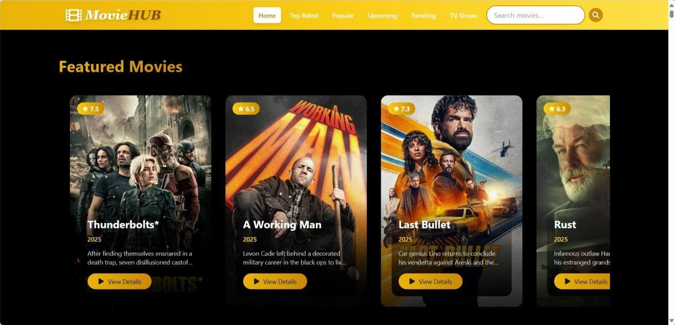

Source code: movie recommendations/index 1.html

Git hub: [https://github.com/pavankumar26dev/movierecommendations.git](https://github.com/devadace/movie-recommendation-system.git)

Win-Win: Users enjoy films faster; platforms grow revenue. 🚀

1. Future Enhancements

Future Enhancements for the AI Movie Recommendation System

1. Advanced Personalization
   * Mood & Context Detection
     + Use voice/tone analysis (from reviews) or time-of-day patterns to suggest films (e.g., "Light comedies after 9 PM").
   * Group Recommendations

- Suggest movies for friends/family by blending preferences (e.g., "80% match for you, 60% for your partner").

1. Enhanced Interactivity
   * "Tinder for Movies" Swipe Feature
     + Like/dislike trailers or posters to refine recommendations in real time.
   * AI Chatbot
     + Conversational interface ("Suggest a thriller with a twist ending").
2. Deeper Integration
   * Cross-Platform Sync
     + Pull watch history from Netflix/Disney+ to unify recommendations.
   * Offline Mode
     + Cache suggestions for users with poor connectivity.
3. Transparency & Control
   * "Why This Recommendation?" Dashboard
     + Show key factors (e.g., "You liked *Inception*, and 90% of fans enjoyed *Tenet*").
   * Manual Preference Tweaks
     + Sliders to adjust genre/decade/actor weightings.
4. Ethical AI
   * Bias Audits
     + Flag/balance over-recommendation of certain genres/demographics.
   * Kid-Safe Mode
     + Auto-filter inappropriate content for family accounts.

Low-Hanging Fruit: Start with swipe-based feedback and manual preference sliders.

Ambitious Add-Ons: Cross-platform sync and mood detection.